Artificial intelligence model for continuous, in-home, posture and health monitoring including user feedback and predictions of clinical assessment.

David Faith Odesola

Table of Contents

List of Figures 2

Introduction 3

Review Methodology 4

Existing Sitting Posture Monitoring Systems 4

History of Smart Sensing chairs 4

Sensing Chair using multiple Pressure Sensors 5

Smart sensing chairs with Mixed Sensor Systems 6

Sensor Technology 6

Different Sitting postures 7

Smart Wheelchair Systems 7

User Feedback System 7

Machine Learning Algorithms 7

Quality of Testing Data 7

Research Gaps 7

Future/Proposed Plans 8

The use and impact of Mobile apps in the healthcare sector 8

Commercialization 8

Conclusions 8

References 9

Appendixes 12

# List of Figures

Figure 1 - A Map of Similar Studies on Smart Sensing Chairs 4

Figure 2 - Force Sensing Resistor 5

## Introduction

According to (Gill et al., 2023) in 2020 alone, musculoskeletal disorders (MSDs) had been ranked 2nd as the leading non-fatal disability which has been affecting more than a billion people worldwide. In Finland, MSD had taken the spotlight as being the leading cause of temporal disability within the nation, through which a lot of resources allocated towards the health services (Martimo, 2010). It might be misconceived that only the elderly are the only ones that suffer from this condition. However, a report by (European Agency for Safety and Health at Work., 2021) has concluded that quite a number of individuals across different age groups are currently suffering from it. It was reported that MSDs can often originate during the childhood stage mainly due to adoption of abnormal postures and low physical activities, which subsequently lead to long-term chronic pain, discomfort, and physical limitations. Traditional examination and treatment procedures most often consist of regular clinical visits and are currently viewed as being inconvenient and costly. According to (Bevan, 2015), MSDs have said to have cost the European Union (EU) over 2% of its gross domestic product (GDP), which is estimated to be over €240bn each year. There is no doubt that this is a steadily growing concern that needs to be properly addressed.

Nowadays, most of the in-office work requires workers to be in a seated position for an extended period, which is said to have adverse effects to one’s health. According to (Arora and Khatri, 2022) and (Putsa et al., 2022), prolong sitting is one of the leading causes of MSDs among office workers. It is therefore recommended that the users should go for small walk breaks after every few hours. The integration of smart sensing chairs that would be actively monitored and provide feedback on one’s health and activity levels would be deemed quite useful.

Furthermore, with the rapid advancement in data sensor technology and Artificial Intelligence in this present age, there should be new and commercialized solutions out there in the market for continuous posture and health monitoring. There is no doubt that these types of systems have the potential of contributing towards the idea of personalized healthcare and improving the quality of life, especially for individuals that are suffering from MSDs.

With that in mind, various research studies have investigated the development of posture monitoring systems which are aimed at detecting bad sitting postures to help the end user in maintaining the right sitting posture at every given time. These types of systems are named as “smart sensing chairs” which goes all the way back to a research study done by (Tan et al., 2001), which fitted a chair with a pressure distribution sensor in order to classify a user’s sitting postures which was just first of many. Furthermore, with a lot of research papers being published in this field, this literature review aims to evaluate related studies and identify research gaps that can pave the way for further investigation into this study. By exploring existing studies, it is possible to gain a better understanding of the current state on the implementation of a smart sensing chair for posture classification and health monitoring.

## Review Methodology

This literature review paper is aimed at conducting a systematic review of similar studies done on smart sensing chair technology. Articles that were examined came from various online publication sources such as Semantic Scholar, Google Scholar, IEEE Explore to name some of them. To aid in the search for the relevant articles though different database systems, a list of important keywords was clearly defined to ensure that the most relevant papers came in the search results. Additionally, some of these keywords were combined to achieve better search results. Below are some of the search terms that was used.

1. Smart Sensing Chair
2. Sitting Posture Recognition
3. Posture Classification
4. Sitting Posture Classification using AI/Machine Learning
5. Sitting Posture Monitoring

## Existing Sitting Posture Monitoring Systems

As previously stated, the development of a sitting posture monitoring system is not an entirely new concept, rather it is an area that has been explored by multiple researchers in the past until this present day. To conduct this literature review, 30+ relevant research papers were carefully selected and examined as seen in Table 1. have been published focusing on the of the use of unobtrusive means for the classification of different sitting positions. Systematically examining these papers would surely some shed light on the most common machine learning algorithms and sensors being used to be able to classify various sitting postures.

### History of Smart Sensing chairs

As previously stated, (Tan et al., 2001) was the first research seen to pioneer the idea of a smart sensing chair that is capable of detecting one’s posture by using pressure distribution sensors integrated into the chair. Over the past few years, various research studies have implemented different variations of these smart sensing chair concepts ranging from different sensors to various classification methods to posture detection. Furthermore, a literature connection map (on the similar studies) done on smart sensing chairs was constructed as shown in Figure 1 below.

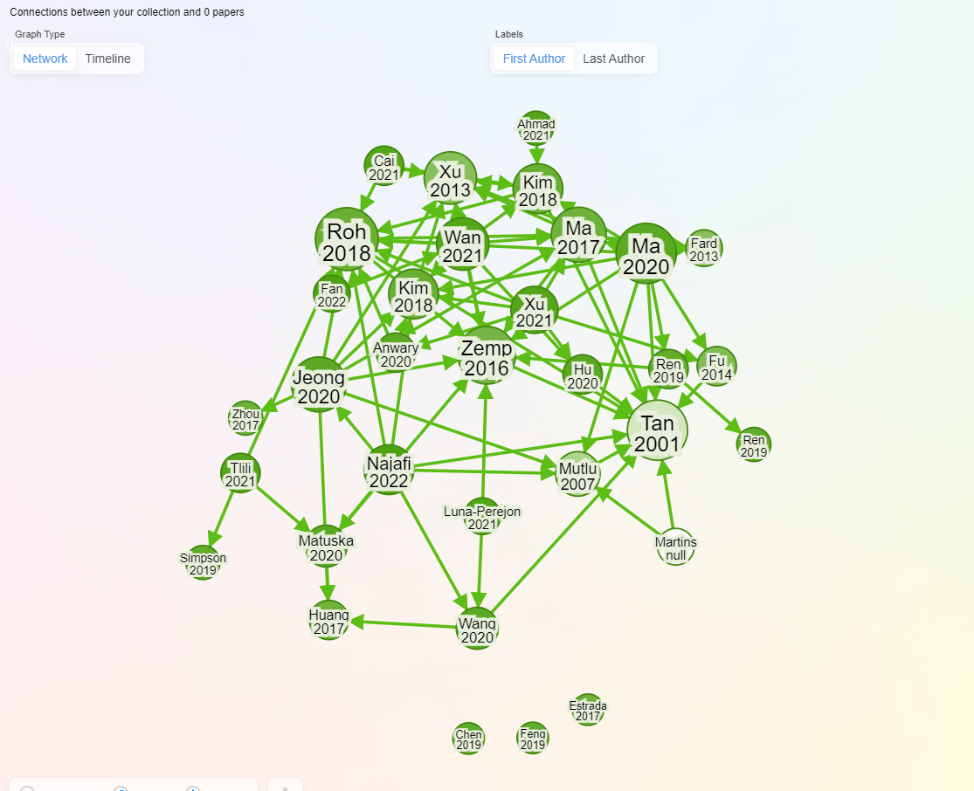

Figure - A Map of Similar Studies on Smart Sensing Chairs

### Sensing Chair using multiple Pressure Sensors

Noticeably, quite a significant number of studies followed the idea of placing the pressure sensors within the seat’s cushion. (Mutlu et al., 2007) integrated 19 different Pressure Sensors (Force Sensing Resistors) into the seat and used SimpleLogistic algorithm to achieve 78% accuracy in classifying 10 different postures. (Tsai et al., 2023) used 13 pressure sensors classify 10 sitting postures and was able to achieve an accuracy of 99.10% using the SVM ML algorithm. (Aminosharieh Najafi et al., 2022) applied 8 sensors (4 on the seating cushion and 4 on the back rest) and used EMN algorithm to classify 8 sitting posture with accuracies reaching 91.68%. Quite a nice addition to the study was the development of a Desktop Graphical User Interface (GUI) application which displayed the senor reading in real-time. (Luna-Perejón et al., 2021) add 6 sensors placed on the seating cushion and resulted 81.5% classification accuracy using SOM (ISOM-SPR) ML algorithm.

### Sensing Chair using Flex Sensors

### Smart sensing chairs with Mixed Sensor Systems

These are smart sensing chairs that utilize at least 2 different types of sensor devices which work hand in hand.

### Sensor Technology

Upon in-depth evaluation of the research papers, it was seen that there are different variations of sensor technology being used in the classification of different sitting postures. Overall, it was concluded that **Force Sensitive Resistors** (FSRs) and **Load Cells** were 2 of the most widely used sensors of choice in the classification of different sitting postures.

*Force Sensing Resistors (FSR)*

Force Sensing Resistors are also known as force sensors which are commonly used to measure the forces applied to its surface area. These sensors work by varying their output resistance based on the pressure being applied to it. Typically, the overall resistance decreases as more pressure is applied (Sadun et al., 2016). To be able to get the reading from this sensor, it normally connected directly to a microcontroller such as an Arduino or similar to get it’s reading. Figure 1 shows an example of how a FSR sensor commonly looks like.

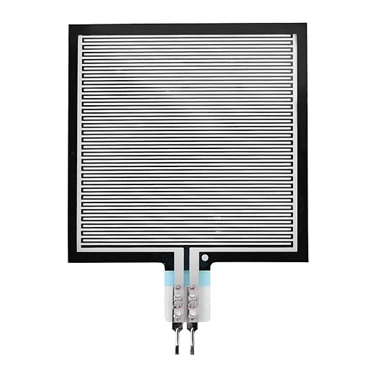

Figure - Force Sensing Resistor

#### Load Cells

Load cells are another variation of force sensor which is commonly used to measure monitor sitting postures. Under the hood, it works by converting the mechanical force being applied to it into digital signals which can be read by microcontrollers. By the looks of it, most research studies

#### Mixed Sensor System

#### Other types of sensors

* Web cameras
* RFID
* Multi-Sensor Combinations

### Different Sitting postures

### Smart Wheelchair Systems

### User Feedback System

### Machine Learning Algorithms

CNN

ANN

### Quality of Testing Data

### Research Gaps

* Most research stops at the posture classification phase.
* Not much effort is focused on the user feedback aspects.

### Future/Proposed Plans

### The use and impact of Mobile apps in the healthcare sector

The use of mobile phones in the healthcare sector has rapidly been gaining in popularity in recent times. Mobile Health (MHealth) apps are mobile applications that are mostly tailored towards assisting both medical professionals and patients in the aspects of health management. According to (Lohnar, 2016), the number of mHealth apps are expected to be on an upward trend.

According to various studies, there are a series of hurdles and issues that must be put into consideration during the implementation of mHealth app.

### Commercialization

## Conclusions

## References

Ahmad, J., Sidén, J. and Andersson, H. (2021) ‘A Proposal of Implementation of Sitting Posture Monitoring System for Wheelchair Utilizing Machine Learning Methods’. *Sensors* 21(19), p. 6349. doi: 10.3390/s21196349.

Aminosharieh Najafi, T., Abramo, A., Kyamakya, K. and Affanni, A. (2022) ‘Development of a Smart Chair Sensors System and Classification of Sitting Postures with Deep Learning Algorithms’. *Sensors* 22(15), p. 5585. doi: 10.3390/s22155585.

Arora, S.N. and Khatri, S. (2022) ‘Prevalence of work-related musculoskeletal disorder in sitting professionals’. *International Journal Of Community Medicine And Public Health* 9(2), p. 892. doi: 10.18203/2394-6040.ijcmph20220259.

Bevan, S. (2015) ‘Economic impact of musculoskeletal disorders (MSDs) on work in Europe’. *Best Practice & Research Clinical Rheumatology* 29(3), pp. 356–373. doi: 10.1016/j.berh.2015.08.002.

Cai, W., Zhao, D., Zhang, M., Xu, Y. and Li, Z. (2021) ‘Improved Self-Organizing Map-Based Unsupervised Learning Algorithm for Sitting Posture Recognition System’. *Sensors* 21(18), p. 6246. doi: 10.3390/s21186246.

Chen, K. (2019) ‘Sitting Posture Recognition Based on OpenPose’. *IOP Conference Series: Materials Science and Engineering* 677(3), p. 032057. doi: 10.1088/1757-899X/677/3/032057.

European Agency for Safety and Health at Work. (2021) *Musculoskeletal disorders among children and young people: prevalence, risk factors and preventive measures : a scoping review.* LU: Publications Office. Available at: https://data.europa.eu/doi/10.2802/511243 (Accessed: 21 November 2023).

Fan, Z., Hu, X., Chen, W.-M., Zhang, D.-W. and Ma, X. (2022) ‘A deep learning based 2-dimensional hip pressure signals analysis method for sitting posture recognition’. *Biomedical Signal Processing and Control* 73, p. 103432. doi: 10.1016/j.bspc.2021.103432.

Fard, F.D., Moghimi, S. and Lotfi, R. (2013) ‘Evaluating Pressure Ulcer Development in Wheelchair-Bound Population Using Sitting Posture Identification’. *Engineering* 05(10), pp. 132–136. doi: 10.4236/eng.2013.510B027.

Feng, L., Li, Z. and Liu, C. (2019) ‘Are you sitting right?-Sitting Posture Recognition Using RF Signals’. in *2019 IEEE Pacific Rim Conference on Communications, Computers and Signal Processing (PACRIM)*. Victoria, BC, Canada: IEEE, pp. 1–6. Available at: https://ieeexplore.ieee.org/document/8985070/ (Accessed: 25 October 2023).

Fu, T. and Macleod, A. (2014) ‘IntelliChair: An Approach for Activity Detection and Prediction via Posture Analysis’. in *2014 International Conference on Intelligent Environments*. China: IEEE, pp. 211–213. Available at: http://ieeexplore.ieee.org/document/6910450/ (Accessed: 20 November 2023).

Gill, T.K. et al. (2023) ‘Global, regional, and national burden of other musculoskeletal disorders, 1990–2020, and projections to 2050: a systematic analysis of the Global Burden of Disease Study 2021’. *The Lancet Rheumatology* 5(11), pp. e670–e682. doi: 10.1016/S2665-9913(23)00232-1.

Hu, Q., Tang, X. and Tang, W. (2020) ‘A Smart Chair Sitting Posture Recognition System Using Flex Sensors and FPGA Implemented Artificial Neural Network’. *IEEE Sensors Journal* 20(14), pp. 8007–8016. doi: 10.1109/JSEN.2020.2980207.

Huang, M., Gibson, I. and Yang, R. (2017) ‘Smart Chair for Monitoring of Sitting Behavior’. *KnE Engineering* 2(2), p. 274. doi: 10.18502/keg.v2i2.626.

Jeong, H. and Park, W. (2021) ‘Developing and Evaluating a Mixed Sensor Smart Chair System for Real-Time Posture Classification: Combining Pressure and Distance Sensors’. *IEEE Journal of Biomedical and Health Informatics* 25(5), pp. 1805–1813. doi: 10.1109/JBHI.2020.3030096.

Kim, J.S. et al. (2018) ‘Predicting Surgical Complications in Patients Undergoing Elective Adult Spinal Deformity Procedures Using Machine Learning’., pp. 762–770. doi: 10.1016/j.jspd.2018.03.003.

Kundaliya, B., Patel, S., Patel, J., Barot, P. and Hadia, S.K. (2022) *An IoT and Cloud Enabled Smart Chair for Detection and Notification of Wrong Seating Posture*. In Review. Available at: https://www.researchsquare.com/article/rs-1999906/v1 (Accessed: 4 November 2023).

Luna-Perejón, F., Montes-Sánchez, J.M., Durán-López, L., Vazquez-Baeza, A., Beasley-Bohórquez, I. and Sevillano-Ramos, J.L. (2021) ‘IoT Device for Sitting Posture Classification Using Artificial Neural Networks’. *Electronics* 10(15), p. 1825. doi: 10.3390/electronics10151825.

Ma, C., Li, W., Gravina, R., Du, J., Li, Q. and Fortino, G. (2020) ‘Smart Cushion-Based Activity Recognition: Prompting Users to Maintain a Healthy Seated Posture’. *IEEE Systems, Man, and Cybernetics Magazine* 6(4), pp. 6–14. doi: 10.1109/MSMC.2019.2962226.

Ma, C., Li, W., Gravina, R. and Fortino, G. (2017) ‘Posture Detection Based on Smart Cushion for Wheelchair Users’. *Sensors* 17(4), p. 719. doi: 10.3390/s17040719.

Martimo, K.-P. (2010) *Musculoskeletal disorders, disability, and work*. Helsinki, Finland: Finnish Institute of Occupational Health.

Martínez-Estrada, M., Vuohijoki, T., Poberznik, A., Shaikh, A., Virkki, J., Gil, I. and Fernández-García, R. (2023) ‘A Smart Chair to Monitor Sitting Posture by Capacitive Textile Sensors’. *Materials* 16(13), p. 4838. doi: 10.3390/ma16134838.

Matuska, S., Paralic, M. and Hudec, R. (2020) ‘A Smart System for Sitting Posture Detection Based on Force Sensors and Mobile Application’. Krejcar, O. (ed.). *Mobile Information Systems* 2020, pp. 1–13. doi: 10.1155/2020/6625797.

Mutlu, B., Krause, A., Forlizzi, J., Guestrin, C. and Hodgins, J. (2007) ‘Robust, low-cost, non-intrusive sensing and recognition of seated postures’. in *Proceedings of the 20th annual ACM symposium on User interface software and technology*. Newport Rhode Island USA: ACM, pp. 149–158. Available at: https://dl.acm.org/doi/10.1145/1294211.1294237 (Accessed: 29 October 2023).

Pereira, L. and Plácido Da Silva, H. (2023) ‘A Novel Smart Chair System for Posture Classification and Invisible ECG Monitoring’. *Sensors* 23(2), p. 719. doi: 10.3390/s23020719.

Putsa, B., Jalayondeja, W., Mekhora, K., Bhuanantanondh, P. and Jalayondeja, C. (2022) ‘Factors associated with reduced risk of musculoskeletal disorders among office workers: a cross-sectional study 2017 to 2020’. *BMC Public Health* 22(1), p. 1503. doi: 10.1186/s12889-022-13940-0.

R, N., Sudhakar, T., Bethanney Janney, J., Krishnamoorthy, N.R., Dhanalakshmi, K. and Vigneshwaran, S. (2023) ‘Sitting posture Analysis using CNN and RCNN’. in *2023 International Conference on Bio Signals, Images, and Instrumentation (ICBSII)*. Chennai, India: IEEE, pp. 1–5. Available at: https://ieeexplore.ieee.org/document/10181038/ (Accessed: 20 November 2023).

Ran, X., Wang, C., Xiao, Y., Gao, X., Zhu, Z. and Chen, B. (2021) ‘A portable sitting posture monitoring system based on a pressure sensor array and machine learning’. *Sensors and Actuators A: Physical* 331, p. 112900. doi: 10.1016/j.sna.2021.112900.

Ren, X., Yu, B., Lu, Y., Chen, Y. and Pu, P. (2019) ‘HealthSit: Designing Posture-Based Interaction to Promote Exercise during Fitness Breaks’. *International Journal of Human–Computer Interaction* 35(10), pp. 870–885. doi: 10.1080/10447318.2018.1506641.

Roh, J., Park, H., Lee, K., Hyeong, J., Kim, S. and Lee, B. (2018) ‘Sitting Posture Monitoring System Based on a Low-Cost Load Cell Using Machine Learning’. *Sensors* 18(2), p. 208. doi: 10.3390/s18010208.

Sadun, A.S., Jalani, J. and Sukor, J.A. (2016) ‘Force Sensing Resistor (FSR): a brief overview and the low-cost sensor for active compliance control’. in Jiang, X., Chen, G., Capi, G., and Ishll, C. (eds.) Tokyo, Japan, p. 1001112. Available at: http://proceedings.spiedigitallibrary.org/proceeding.aspx?doi=10.1117/12.2242950 (Accessed: 23 November 2023).

Tan, H.Z., Slivovsky, L.A. and Pentland, A. (2001) ‘A sensing chair using pressure distribution sensors’. *IEEE/ASME Transactions on Mechatronics* 6(3), pp. 261–268. doi: 10.1109/3516.951364.

Tsai, M.-C., Chu, E.T.-H. and Lee, C.-R. (2023) ‘An Automated Sitting Posture Recognition System Utilizing Pressure Sensors’. *Sensors* 23(13), p. 5894. doi: 10.3390/s23135894.

Wang, J., Hafidh, B., Dong, H. and El Saddik, A. (2021) ‘Sitting Posture Recognition Using a Spiking Neural Network’. *IEEE Sensors Journal* 21(2), pp. 1779–1786. doi: 10.1109/JSEN.2020.3016611.

Xu, W., Huang, M.-C., Amini, N., He, L. and Sarrafzadeh, M. (2013) ‘eCushion: A Textile Pressure Sensor Array Design and Calibration for Sitting Posture Analysis’. *IEEE Sensors Journal* 13(10), pp. 3926–3934. doi: 10.1109/JSEN.2013.2259589.

Zemp, R., Tanadini, M., Plüss, S., Schnüriger, K., Singh, N.B., Taylor, W.R. and Lorenzetti, S. (2016) ‘Application of Machine Learning Approaches for Classifying Sitting Posture Based on Force and Acceleration Sensors’. *BioMed Research International* 2016, pp. 1–9. doi: 10.1155/2016/5978489.

## Appendixes

Tables 1 – Sitting Posture Monitoring Research Papers

|  |  |  |  |  |  |  |  |  |
| --- | --- | --- | --- | --- | --- | --- | --- | --- |
| **Reference** | **Sensors** | **Number of Postures** | **Classification Method** | **Classification Accuracy** | **Test Subjects** | **Limitations** | **User Feedback System** | **Is Realtime** |
| (Pereira and Plácido Da Silva, 2023) | Load Cell - Posture Conductive Nappa - ECG | 5 | K-NN | 98.50% | 10 | Not used in a real-life setting | |  |
| (Ahmad et al., 2021) | Screen Printed Pressure units (16 Array) | 4 | LightGBM | 99.03% | 32 | Not used in a real life setting | |  |
| (Huang et al., 2017) | 52 by 44 Piezo-Resistive Sensor Array | 8 | ANN | 92.20% |  | No accuracy |  |  |
| (Martínez-Estrada et al., 2023) | 10 Presence textile capacitive sensor (embroidered) | 8 |  |  | 5 |  |  |  |
| (Matuska et al., 2020) | 6 Flexible Force Sensors | 9 | Average Standard deviation with 3 Threshold values to determine good/bad postures (Non AI) |  | 12 |  |  |  |
| (Aminosharieh Najafi et al., 2022) | 8 Force Sensing Resistors | 8 | EMNM | 92.68% | 40 |  |  |  |
| (Kundaliya et al., 2022) | A502 Force Sensor & Flex Sensor | 5 |  |  |  | No accuracy |  |  |
| (Ran et al., 2021) | Pressure Array (IMMM00014, I-MOTION | 7 | 5 Layer Artificial Intelligence | 97.07% | 100 |  |  |  |
| (Roh et al., 2018) | 4 Load Cells | 6 | SVM using RBF kernel | 97.94% | 24 | No accuracy |  |  |
| (Kim et al., 2018) | Textile Pressure Sensors (Conductive Ni-Ti alloy fiber) | 7 |  |  |  | No accuracy |  |  |
| (Feng et al., 2019) | RFID tags | 3 | RF | 99.27% | 14 | Small number of postures | |  |
| (Hu et al., 2020) | 6 Flexible Force Sensors | 7 | 2 Layer ANN | 97.43% | 11 |  |  |  |
| (Jeong and Park, 2021) | 6 Pressure Sensors & 6 Infrared Reflective Distance Sensors | 11 | K-NN | 92% | 36 |  |  |  |
| Martins et al. 2013 | 8 | ANN | 93.40% | 30 |  |  |  | |
| (Mutlu et al., 2007) | 10 | SimpleLogistic | 87% | 46 |  |  |  | |
| (Ma et al., 2017) | 5 | Decision Tree (J48) | 99.47% | 12 |  |  |  | |
| (Zemp et al., 2016) | 16 Force Sensor | 7 | Random Forest | 81% - 98% | 41 |  |  |  |
| (Tsai et al., 2023) | 13 pressure sensors (FSR-406) | 10 | SVM (Linear) | 99.10% | 20 |  |  |  |
| (Kim et al., 2018) | 8x8 Pressure Sensor | 5 | CNN | 95.30% | 10 |  |  |  |
| (Luna-Perejón et al., 2021) | 6 Force Sensitive Resistors (FSR) | 7 | ANN | 81.00% | 12 | Low accuracy |  |  |
| (Cai et al., 2021) | 3x3 Flexible Array Pressure Sensor | 6 | SOM (ISOM-SPR) | 95.67% | 40 | Few Test Samples | Mobile App |  |
| (Fan et al., 2022) | 44 × 52 Pressure Sensor Array | 5 | CNN | 99.82% | 8 | _ Few Test Samples _ Lack of detection of spine curvatures | N/A | YES |
| (Chen, 2019) | Astra3D Sensor |  | CNN | 90% |  | Privacy issue with Camera Can't work in bad lighting Lack of proper user feedback system for posture correction | PC Screen (Correct/Wrong) | YES |
| (Ma et al., 2020) | Pressure array | 5 | Decision Tree | 89% |  |  |  |  |
| (Fard et al., 2013) | 64 Pressure Sensors Array (40x50) cm2 | 4 |  |  | 5 | Limited number of subjects | N/A | NO |
| (Ren et al., 2019) | 6 Square-Type force Sensing Resistors |  | ANN |  |  |  | RGB LED | YES |
| (Wang et al., 2021) | 2 Pressure Sensors Array (FSR) | 15 | SNN (LSM) | 88.52% | 19 | Lack of focus on the User feedback aspects Not used in real-life setting to prove it's usefulness | Desktop App | YES |
| (Xu et al., 2013) | Electrical Textile | 7 | Naive Bayes Network | 85.90% | 14 | The mobile just visualizes the sitting pressure distribution, however the value of this is not really seen to the end user's persepective. No sort of recommendation system. | Mobile App | Yes |
| (R et al., 2023) | Web Camera | 6 | RCNN & CNN | 92.50% |  | No good user feedback/recommendation system | N/A | YES |
| (Fu and Macleod, 2014) | 8 Force Sensing Resistors (FSR) FSR 406 |  | HMM Decision Tree |  |  | Lacks Proper testing  There's a need to implement a feedback system | N/A | YES |